3D-CMCC-FEM
(Coupled Model Carbon Cycle)
BioGeoChemical and Biophysical
Forest Ecosystem Model

User’s Guide (v.5.x)
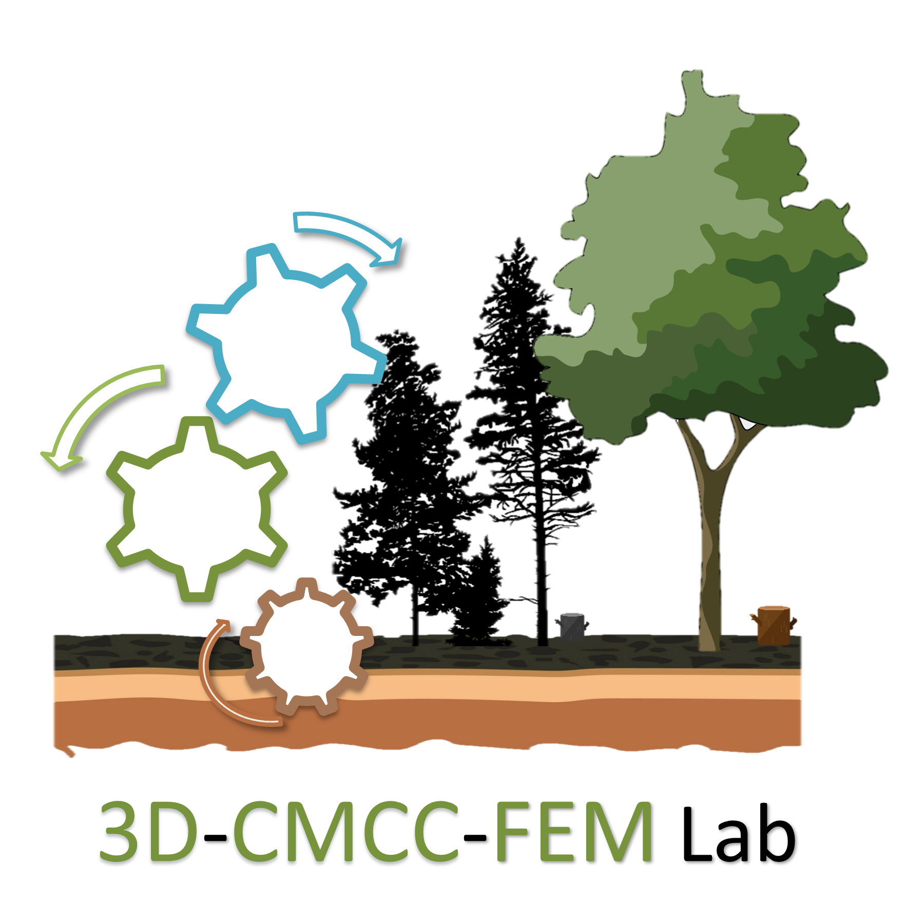
Website: www.3d-cmcc-fem.com

National Research Council of Italy
Institute for Agriculture and Forestry Systems in the Mediterranean (CNR-ISAFOM)
Via Cavour, 4/6 - 87036 Rende (CS) Italy

University of Tuscia
Department for Innovation in Biological, Agro-food and Forest systems (DIBAF)

Via S. Camillo de Lellis snc, 01100 Viterbo (VT) Italy

Lab contacts
Alessio Collalti (Lab. Head)
alessio.collalti@cnr.it
Institute for Agriculture and Forestry Systems in the Mediterranean of the National Research Council of Italy (CNR-ISAFOM)
Via Cavour, 4/6 - 87036 Rende (CS) Italy
Department for innovation in biological, agro-food and forest systems (DIBAF)
University of Tuscia
Via S. Camillo de Lellis snc, 01100 Viterbo (VT) Italy

Alessio Ribeca
a.ribeca@unitus.it
Department for innovation in biological, agro-food and forest systems (DIBAF)
University of Tuscia
Via S. Camillo de Lellis snc, 01100 Viterbo (VT) Italy

Carlo Trotta
trottacarlo@unitus.it
Department for innovation in biological, agro-food and forest systems (DIBAF)
University of Tuscia
Via S. Camillo de Lellis snc, 01100 Viterbo (VT) Italy

Corrado Biondo
corrado.biondo@cmcc.it
Euro-Mediterranean Centre on Climate Changes (CMCC)
Impacts on Agriculture, Forests and Ecosystem Services Division (IAFES)
Viale Trieste 127, 01100 Viterbo (Italy)

Department for innovation in biological, agro-food and forest systems (DIBAF)
University of Tuscia
Via S. Camillo de Lellis snc, 01100 Viterbo (VT) Italy

Daniela Dalmonech
daniela.dalmonech@gmail.com
Friesenstrasse 5, Potsdam 14482

Gina Marano
gina.marano@unina.it
Interdepartmental Research Center on the "Earth Critical Zone" Department of Agriculture, University of Naples "Federico II"
Via Universitá 100, 80055 Portici (NA) Italy

Index

1. How to ask for the code 4
2. Model description 4
3. Referencing the 3D-CMCC-FEM version 5.x 4
4. How to use the 3D-CMCC-FEM 6
4.1 Code characteristics 6
4.2 Eclipse usage instructions 6
4.3 How to increase Eclipse available heap size 7
4.6 How to work on Eclipse for bash scripts 8
4.7 3D-CMCC-FEM Usage 8
5. Run the model 13
6. Settings file 13
6.1 Initialization file 16
7. Parameterization file 17
8. Input files 22
8.1 Overview 22
8.2 Meteorological Data File 22
8.3 Soil file 23
8.4 Topo file 25
8.5 CO₂ file 25
9. Output files 26
9.1 Overview 26
9.2 Annual Outputs 26
9.3 Monthly Outputs 30
9.4 Daily Outputs 31
10. Questions or comments 34

1. How to ask for the code
The 3D-CMCC-FEM (both versions: Light Use Efficiency and the fully BioGeoChemical version). Versions 5.x code are open. You can get a free copy of the code online from: (GitHub Repository) https://github.com/3D-CMCC-CNR-FEM/3D-CMCC-CNR

2. Model description
The 3D-CMCC-FEM model simulates the dynamics occurring in heterogeneous forests with different plant species, also if simultaneously composed by evergreen and deciduous, for different age, diameter, and height classes. The model is able to reproduce forests with a complex canopy structure constituted by cohorts competing with each other for light and water. The model simulates carbon fluxes, in terms of gross and net primary productivity (GPP and NPP, respectively), partitioning and allocation in the main plant compartments (stem, branch, leaf, fruit, fine and coarse root, non-structural carbon). In the recent versions, nitrogen fluxes and allocation, in the same carbon pools, are also reproduced. The 3D-CMCC-FEM also takes into account management practices, as thinning and harvest, to predict their effects on forest growth and carbon sequestration. The 3D-CMCC-FEM is written in C-programming language and divided into several subroutines. To run the model, some input data are required. The meteorological forcing variables, on a daily time step, are represented by average, minimum and maximum air temperature, shortwave solar radiation, precipitation, vapor pressure deficit (or relative humidity). The model also needs some basic information about soil, such as soil depth and texture (clay, silt and sand fractions), as well as the forest stand information referred to plant species, ages, diameters, heights and stand density. An additional input is represented by species-specific eco-physiological data for the model parameterization.
The 3D-CMCC-FEM is primarily a research tool, and many versions have been developed for particular purposes. The CNR and University of Tuscia maintain benchmark code versions for public release and update these benchmark versions periodically as new knowledge is gained on the research front. The code and executables accompanying this file represent the most recent benchmark version.

3. Referencing the 3D-CMCC-FEM versions 5.x
If you use 3D-CMCC-FEM in your research, please include the following acknowledgment in the relevant manuscript:
“3D-CMCC-FEM, Version 5.x was provided by Alessio Collalti, from:
- National Research Council of Italy, Institute for Agricultural and Forestry Systems in the Mediterranean (ISAFOM)
- University of Tuscia, Department for Innovation in Biological, Agro-food and Forest systems (DIBAF)

Please also reference the following citation as the most recent and complete description of the current model version:
v.4.0 (not more in use)
"A process-based model to simulate growth and dynamics in forests with complex structure: evaluation and use of 3D-CMCC Forest Ecosystem Model in a deciduous forest in Central Italy". A. Collalti, L. Perugini, T. Chiti, A. Nolè, G. Matteucci, R. Valentini. Ecological modeling 2014. https://doi.org/10.1016/j.ecolmodel.2013.09.016.
Collalti, A. “Sviluppo di un modello dinamico ecologico-forestale per foreste a struttura complessa”. April 2011. PhD Thesis, PhD Advisor: Riccardo Valentini. DOI: 10.13140/RG.2.2.17900.92800. http://dspace.unitus.it/bitstream/2067/2398/1/acollalti_tesid.pdf
v.5.1.1 (not more in use)
"Validation of 3D-CMCC Forest Ecosystem Model (v.5.1) against eddy covariance data for 10 European forest sites". A. Collalti, S. Marconi, A. Ibrom, C. Trotta, A. Anav, E. D’Andrea, G. Matteucci, L. Montagnani, B. Gielen, I. Mammarella, T. Grünwald, A. Knohl, F. Berninger, Y. Zhao, R. Valentini and M. Santini, Geosc. Model Dev., 9, 479-504, 2016. https://doi.org/10.5194/gmd-9-479-2016.
v.PSM (not more in use)
“The Role of Respiration in Estimation of Net Carbon Cycle: Coupling Soil Carbon Dynamics and Canopy Turnover in a Novel Version of 3D-CMCC Forest Ecosystem Model”. S. Marconi, T. Chiti, A. Nolè, R. Valentini and A. Collalti. Forests 2017. https://doi.org/10.3390/f8060220.
v.5.4
“Thinning can reduce losses in carbon use efficiency and carbon stocks in managed forests under warmer climate”. Collalti A., Trotta C., Keenan T.F., Ibrom A., Lamberty B.B., Gröte R., Vicca S., Reyer C.P.O., Migliavacca M., Veroustraete F., Anav A., Campioli M., Scoccimarro E., Šigut L., Grieco E., Cescatti A., and Matteucci G. Journal of Advances in Modelling Earth System 2018. https://doi.org/10.1029/2018MS001275.
“The sensitivity of the forest carbon budget shifts across processes along with stand development and climate change”. Collalti A., Thornton P.E., Cescatti A., Rita A., Borghetti M., Nolè A., Trotta C., Ciais P., Matteucci G. Ecological Applications 2018. https://doi.org/10.1002/eap.1837.
Pellicone G. “Climate change mitigation by forests: a case study on the role of management on carbon dynamics of a pine forest in South Italy”. 2018. Ph.D. Thesis.

v.5.5
“Plant respiration: Controlled by photosynthesis or biomass?” Collalti A., Tjoelker M.G., Hoch G., Mäkelä A., Guidolotti G., Heskel M., Petit G., Ryan M.G., Battipaglia G., Matteucci G., Prentice I.C. Global Change Biology. https://doi.org/10.1111/gcb.14857
If you have made any significant modifications to the code, please mention them in your manuscript.
This User’s Guide is the only documentation released with 3D-CMCC-FEM.
The code itself contains extensive internal documentation, and users with specific questions about the algorithms used to estimate particular processes should read the comments in the appropriate source code files.
The file treemodel.c contains references to all the core science routines and is a good starting point for this kind of inquiry. The files matrix.c defines the data structures that are used to pass information between the process modules and includes both a short text description and the units for each internal variable.
Shall you have questions about the code, appropriate model applications, possible programming errors, etc., please read this entire guide first, then feel free to contact us.

4. How to use the 3D-CMCC-FEM

4.1 Code characteristics
3D-CMCC-FEM is primarily developed on UNIX-Linux, X-Ubuntu with Eclipse IDE Platforms and is compiled using GNU GCC 4.7.2.
IMPORTANT: Be sure to execute 3D-CMCC-FEM on a Linux machine with architecture X86_64 (64 bit), otherwise you firstly need to rebuild code to obtain the object files needed for runs.

4.2 Eclipse usage instructions
To Run the model in Eclipse CDT, using a sub-versioned version of the model simply follow these steps (be sure if you use Eclipse to have installed Git and Egit and to have an internet connection):
- Save the 3D-CMCC-FEM Model directory in the path you are going to use as Eclipse Workspace;
- to prevent error from netcdf libraries, open terminal:
$ sudo apt-get install netcdf-bin
$ sudo apt-get install libnetcdf-dev
- To make the model work under Eclipse CDT (any version) using Git you shall follow this guide:
- download from terminal Git and build-essential
  - $ sudo apt-get install build-essential
  - $ sudo apt-get install git
- download from Ubuntu software center jre 7-8 or jdk (if not installed)
  - $ sudo apt-get install default-jdk
4) Download from eclipse site the most recent version of Eclipse IDE for C/C++ Developers
5) Open Eclipse and set your Workspace as the same path in which you've placed the Model's folder - to do so click on File, then "switch Workspace" and click on "Other..."; here input your current path;
6) File -> Import -> Git -> Projects from Git -> Clone Url and in URL please paste the code version you find over the GitHub https://github.com/3D-CMCC-CNR-FEM/3D-CMCC-FEM
For NETCDF file you need to add libraries within eclipse through:
Project->Properties->C/C++ Build->Settings->Cross G++ Linker->Libraries-> in Libraries (-l) add "netcdf"->OK

4.3 How to increase Eclipse available heap size
Some JVMs put restrictions on the total amount of memory available on the heap. If you are getting OutOfMemoryErrors while running Eclipse, the VM can be told to let the heap grow to a larger amount by passing the -vmargs command to the Eclipse launcher (http://wiki.eclipse.org/FAQ_How_do_I_increase_the_heap_size_available_to_Eclipse%3F). Here follows a short how to:
1) Search for the location of your eclipse.ini file (usually usr/lib/eclipse);
2) Open eclipse.ini using gedit command from terminal as super user (sudo gedit eclipse.ini);
3) BE EXTREMELY CAREFUL TO FOLLOW ECLIPSE DEVELOPERS RULES
- Each option and each argument to an option must be on its own line.
- All lines after -vmargs are passed as arguments to the JVM, so all arguments and options for eclipse must be specified before -vmargs (just like when you use arguments on the command-line).
- Any use of -vmargs on the command-line replaces all -vmargs settings in the .ini file unless –launcher .appendVmargs is specified either in the .ini file or on the command-line. (doc).
4) in line 12 change -Xms40m into -Xms512m (just replace 40 with 512 without changing the rest of the line).
5) in line 13 change -Xmx256m into -Xmx1024m (just replace 256 with 11024 without changing the rest of the line).
6) save eclipse.ini and restart eclipse.

4.6 How to work on Eclipse for bash scripts
To work in Bash Shell scripts within the ECLISPE IDE you need to install ShellED eclipse package through the web.

4.7 3D-CMCC-FEM Usage
3D-CMCC-FEM is a command line program, and its behavior is controlled by several command line options:
-i input path | i.e.: -i c:\input\directory\
-o output path | i.e.: -o c:\output\directory\
-p parameterization directory | i.e.: -i c:\parameterization\directory\
-d dataset filename stored into input directory | i.e.: -d input.txt
-m met filename list stored into input directory | i.e.: -m 1999.txt, 2003.txt, 2009.txt
-s soil filename stored into input directory | i.e.: -s soil.txt or soil.nc
-t topo filename stored into input directory | i.e.: -t topo.txt or topo.nc
-c settings filename stored into input directory | i.e.: -c settings.txt
-k CO₂ atmospheric concentration file | i.e.: -k co2_conc.txt
-n ndep file | i.e.: -n ndep.txt
-r output vars list | i.e.: -r output_vars.lst
-u benchmark path | (for model developers)
-h | print this help

More specifically:
-i | this is not a mandatory parameter. if not used, input files will be searched where program is.
-o | this is not a mandatory parameter. If not used, output files will be created where program is.
-p | this is not a mandatory parameter. If not used, parameterization file will be searched where program is.
-d “stand”  mandatory parameter | This file will be searched in input path, if specified. It can be an ASCII or NETCDF file. You can use '//' for comment it. ASCII file must have following header, separated by a comma:  Year, x, y, Age, Species, Management, N, Stool, AvDBH, Height, Lai  Please see [SPECIES]* section and [MANAGEMENT]** section to check allowed values. Same columns name applies to variables name in NETCDF version of file.
-m “meteo”  mandatory parameter | This file will be searched in input path, if specified. It can be an ASCII or NETCDF file. You can specify a .lst ( list ) file if you have separated values.  List file must contain the name of NETCDF files to import, one row for variable i.e.:  6_WS_f_2000_2001_123_456.nc  6_TOT_PREC_2000_2001_123_456.nc  6_SWC_2000_2001_123_456.nc  6_TMAX_2M_2000_2001_123_456.nc  6_TMIN_2M_2000_2001_123_456.nc  6_TSOIL_2000_2001_123_456.nc  6_VPD_2000_2001_123_456.nc  6_ET_2000_2001_123_456.nc  6_LAI_2000_2001_123_456.nc  6_RADS_2000_2001_123_456.nc  ASCII file must have following header, separated by a tab (/t) :  Year Month n_days Rg_f Ta_f Tmax Tmin Rh_f Ts_f Precip SWC LAI ET WS_f  Same columns name applies to variables name in NETCDF version of file.
-s “soil”  mandatory parameter | This file will be searched in input path, if specified. It can be an ASCII or NETCDF file. ASCII file must have following header, separated by a comma:  X,Y,LANDUSE,LAT,LON,CLAY_PERC,SILT_PERC, SAND_PERC,SOIL_DEPTH,FR,FN0,FNN,M0,LITTERC, LITTERN,SOILC,SOILN,DEADWOODC  Please see [LANDUSE] section to check allowed values. Same columns name applies to variables name in NETCDF version of file.
-t “topography” mandatory parameter | This file will be searched in input path, if specified. It can be an ASCII or NETCDF file.  ASCII file must have following header, separated by a comma: X,Y,ELEV  Same columns name applies to variables name in NETCDF version of file.
-c “model setting” mandatory parameter | This file will be searched in input path, if specified.  It must be an ASCII file. You can put comment using '//' token;  The file must contain the rows descripted in the “Settings file” section.
-k “atmospheric CO2” concentration” mandatory parameter only if CO2_trans in settings file is setted on 'on' or 'var' | This file will be searched in input path, if specified.  It must be an ASCII file and must have following header, separated by a tab (/t):  year CO2_ppm
-n “nitrogen deposition” mandatory parameter only if Ndep_fixed in settings file is setted on 'off' | This file will be searched in input path, if specified.  It must be an ASCII file and must have following header, separated by a tab (/t):  year ndep
-r  not mandatory | Use it if you want export variables values inside a NETCDF file.  You can specify more variables per row using a comma as delimiter.  Each variable must have "daily_", "monthly_" or "annual_" prefix. i.e.:  daily_gpp,  annual_GPP  daily_ar  monthly_ar  annual_npp  In previous example, daily values for GPP and AR are exported. Monthly values for AR are exported and annual values for GPP and NPP are exported. Files will be created in output path if any or where program is.
[SPECIES]*
Following species can be used on relative column inside an ASCII dataset (without indexes)
Please note that you must use their indexes if you use a NETCDF file.
0,Fagussylvatica
1,Castaneasativa
2,Larixdecidua
3,Piceaabies
4,Pinussylvestris
5,Quercuscerris
6,Quercusilex
7,Quercusrobur
8,quercus_deciduous
9,quercus_evergreen
[MANAGEMENT]**
Following type of management can be used on relative column inside as ASCII dataset (without indexes). Please note that you must use their indexes if you use a NETCDF file.
T is for timber
C is for coppice (under development)
0,T
1,C
[LANDUSE]***
Following type of landuse can be used on relative column inside as ASCII dataset (without indexes).
Please note that you must use their indexes if you use a NETCDF file.
F is for forest
Z is for crop (currently not implemented)
0,F
1,Z

5. Run the model
Be sure to set the right arguments passed to the project and go into bin directory:
cd bin
Run executable with default parameters:
3D-CMCC-Forest-Model -i input -o output -p parameterization -d sitename_stand.txt
-m sitename_meteo_firstyear.txt -s sitename_soil.txt -t sitename_topo.txt
-c sitename_settings.txt -k CO2_hist.txt > log.txt

6. Settings file
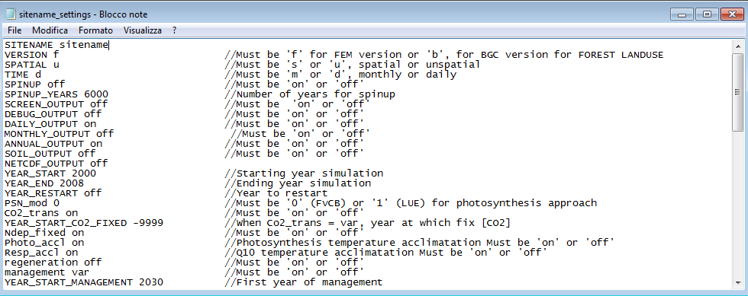

Example of settings file
The file "sitename_settings.txt" permits to set the model run, choosing:
SITENAME | Name of site
VERSION | Must be 'f' for FEM version or 'b', for BGC version for FOREST LANDUSE
SPATIAL | Must be 's' or 'u', spatial or un-spatial
TIME | Must be 'm' or 'd', monthly or daily
SPINUP | Must be 'on' or 'off'
SPINUP_YEARS | Number of years for spin-up (under development)
SCREEN_OUTPUT | Must be ‘on' or 'off'
DEBUG_OUTPUT | Must be 'on' or 'off'
DAILY_OUTPUT | Must be 'on' or 'off'
MONTHLY_OUTPUT | Must be 'on' or 'off'
ANNUAL_OUTPUT | Must be 'on' or 'off'
SOIL_OUTPUT | Must be 'on' or 'off'
NETCDF_OUTPUT | Must be ‘off’
YEAR_START | Starting year simulation
YEAR_END | Ending year simulation
YEAR_RESTART | Year to restart. Must be ‘off’
PSN_mod | Must be '0' (FvCB version) or '1' (LUE version) for photosynthesis approach
CO2_trans | Must be 'on' or 'off'
YEAR_START_CO2_FIXED | -9999 . When Co2_trans = var, year at which fix [CO2]
Ndep_fixed | Must be 'on' or 'off' (under development)
Photo_accl | Photosynthesis temperature acclimation Must be 'on' or 'off'
Resp_accl | Q10 temperature acclimation. Must be 'on' or 'off'
regeneration | Must be 'on' or 'off'
management | Must be 'on' or 'off'
YEAR_START_MANAGEMENT | First year of management
Progn_Aut_Resp | Prognostic autotrophic respiration. Must be 'on' or 'off', if off Y values are used
SIZECELL | Its value must be within 10 and 100 (unity measure is meter: 10 = 10x10 = 100m⁻²2)
Y 0.48 | Fixed_Aut_Resp_rate Assimilate use efficiency-Respiration rate-GPP/NPP
CO2CONC 368.865 | CO2 concentration refers to 2000 as ISIMIP PROTOCOL
CO2_INCR 0.01 | 1% increment
INIT_FRAC_MAXASW 1 | 0.1 Minimum fraction of asw based on maxasw (wilting point) (unchanged)
TREE_LAYER_LIMIT | Define differences among tree heights in meters classes to d define number of layers in un-spatial version
SOIL_LAYER | Define soil layer/s to consider
THINNING_REGIME | Thinning regime (Above or Below)
REPLANTED_SPECIES | Species name of replanted trees (mandatory)
REPLANTED_MANAGEMENT | (T) management of replanted trees (should be only T) (mandatory)
REPLANTED_TREE | Number of replanted trees (mandatory)
REPLANTED_AGE | (yr) age of replanted trees (mandatory)
REPLANTED_AVDBH | (cm) average dbh of replanted trees (mandatory)
REPLANTED_LAI | (m²m⁻²) LAI for replanted trees (mandatory for evergreen useless for deciduous)
REPLANTED_HEIGHT | (m) height of replanted trees (mandatory)
REPLANTED_WS | (tDM ha⁻¹) stem biomass of replanted trees (optional)
REPLANTED_WCR | (tDM ha⁻¹) coarse root biomass of replanted trees (optional)
REPLANTED_WFR | (tDM ha⁻¹) fine root biomass of replanted trees (optional)
REPLANTED_WL | (tDM ha⁻¹) leaf biomass of replanted trees (optional for evergreen if LAI!= 0, otherwise useless)
REPLANTED_WBB | (tDM ha⁻¹) branch biomass of replanted trees (optional)
REGENERATION_SPECIES none | NOT USED it comes from species that produces seeds
REGENERATION_MANAGEMENT | (T) management of replanted trees (should be only T) (mandatory)
REGENERATION_N_TREE -9999 | number of replanted trees (mandatory) (NOT USED)
REGENERATION_AGE 1 | (yr) age of regeneration trees (mandatory) (SHOULD BE ALWAYS 1)
REGENERATION_AVDBH | (cm) average dbh of regeneration trees (mandatory)
REGENERATION_LAI 0.0 | (m²m⁻²) LAI for regeneration trees (mandatory for evergreen, useless for deciduous)
REGENERATION_HEIGHT | (m) height of replanted trees (mandatory)
REGENERATION_WS 0.0 | (tDM ha⁻¹) stem biomass of regeneration trees (optional)
REGENERATION_WCR 0.0 | (tDM/ha) coarse root biomass of regeneration trees (optional)
REGENERATION_WFR 0.0 | (tDM ha⁻¹) fine root biomass of regeneration trees (optional)
REGENERATION_WL 0.0 | (tDM ha⁻¹) leaf biomass of regeneration trees (optional for evergreen if LAI!= 0, otherwise useless)
REGENERATION_WBB | (tDM ha⁻¹) branch biomass of regeneration trees (optional)
PRUNING | Must be 'on' or 'off'
IRRIGATION | Must be 'on' or 'off'

6.1 Initialization file
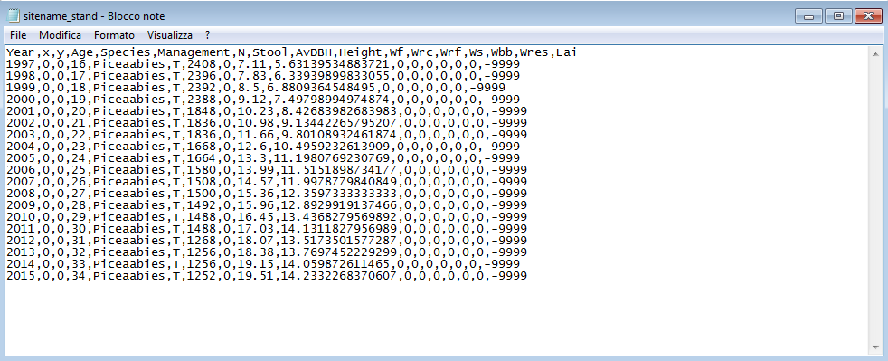
Example of stand file
The first required input file is called the "sitename_stand.txt". It provides information about the stand conditions.
Example for a cell resolution of 10 x 10 meters cell X = 0, Y = 0:
Year,x,y,Age,Species,Management,N,Stool,AvDBH,Height,Wf,Wrc,Wrf,Ws,Wbb,Wres,Lai
1997,0,0,16,Piceaabies,T,2408,0,7.11,5.63139534883721,0,0,0,0,0,0,-9999
..,..,..,..,..,..,..,..,..,..,..,..,..,..,..,..,..,..,..,..
..,..,..,..,..,..,..,..,..,..,..,..,..,..,..,..,..,..,..,..
2015,0,0,34,Piceaabies,T,1252,0,19.51,14.2332268370607,0,0,0,0,0,0,-9999
The text file must be created following this logic architecture
- for each tree height class define the number of age classes and their values
-- for each height->dbh class
--- for each height->dbh->age class
---- for each height->dbh->age->species class define its state variables:
- Year: Reference year
- X,Y: 0,0
- Age: Age of trees (years)
- Species: Name of specie
- Management: (T = timber, C = coppice)
- N: N of trees per area for that class (Num tree cell size⁻¹)
- Stool: N of stool per area (if Management is set to C) (Num tree cell size⁻¹)
- AvDBH: Average diameter at breast height (cm) for that class
- Height: Tree height (m) for that class
- Wf: 0.0 (foliage biomass in tDM ha⁻¹) for that class
- Wrc: 0.0 (coarse root biomass in tDM ha⁻¹) for that class
- Wrf: 0.0 (fine root biomass in tDM ha⁻¹) for that class
- Ws: 0.0 (stem biomass in tDM ha⁻¹) for that class
- Wbb: 0.0 (branch and bark biomass in tDM ha⁻¹) for that class
- Wres: 0.0 (reserve in tDM ha⁻¹) for that class
- LAI: Leaf area index (m² m⁻²) for that class

7. Parameterization file
The parameterization file is the species eco-physiological constants file, named with specie to simulate (e.g."Fagussylvatica.txt").
Comments are allowed in the parameter file. Comments can appear almost anywhere, must begin with two forward slash characters '//', at the end of the line. Example parameter files are provided. Parameter definition and its value must be separated by one-tab character.
It contains the following parameters:
LIGHT_TOL | Light Tolerance 4 = very shade intolerant (canopy coverage = 90%), 3 = shade intolerant (canopy coverage 100%), 2 = shade tolerant (canopy coverage = 110%), 1 = very shade tolerant (canopy coverage = 120%)
PHENOLOGY | 0.1 = deciduous broadleaf, 0.2 = deciduous needle leaf, 1.1 = broad leaf evergreen, 1.2 = needle leaf evergreen
ALPHA | Canopy quantum efficiency (molC molPAR⁻¹)
EPSILONgCMJ | Light Use Efficiency (gC MJ⁻¹) (used if ALPHA is not available)
K | Extinction coefficient for absorption of PAR by canopy
ALBEDO | Canopy albedo
INT_COEFF | Precipitation interception coefficient
SLA_AVG0 | Average Specific Leaf Area m² KgC⁻¹ for sunlit/shaded leaves (juvenile)
SLA_AVG1 | Average Specific Leaf Area m² KgC⁻¹ for sunlit/shaded leaves (mature)
TSLA | Age at which SLA_AVG = (SLA_AVG1 + SLA_AVG0 )/2
SLA_RATIO | (DIM) ratio of shaded to sunlit projected SLA
LAI_RATIO | (DIM) all-sided to projected leaf area ratio
FRACBB0 | Branch and Bark fraction at age 0 (m² Kg⁻¹)
FRACBB1 | Branch and Bark fraction for mature stands (m² Kg⁻¹)
TBB | Age at which fracBB = (FRACBB0 + FRACBB1)/2
RHO0 | Minimum Basic Density for young Trees (tDM m⁻³)
RHO1 | Maximum Basic Density for mature Trees (tDM m⁻³)
TRHO | Age at which rho = (RHOMIN + RHOMAX)/2
FORM_FACTOR | Stem form factor (adim)
COEFFCOND | Define stomatal response to VPD in m sec⁻¹
BLCOND | Canopy Boundary Layer conductance m sec⁻¹
MAXCOND | Maximum Leaf Conductance in m sec⁻¹
CUTCOND | Cuticular conductance in m sec⁻¹
MAXAGE | Maximum tree age (years)
RAGE | Relative Age to give fAGE = 0.5
NAGE | Power of relative Age in function for Age
GROWTHTMIN | Minimum temperature for growth °C
GROWTHTMAX | Maximum temperature for growth °C
GROWTHTOPT | Optimum temperature for growth °C
GROWTHSTART | Thermic sum value for starting growth in °C
MINDAYLENGTH | Minimum day length for phenology (days)
SWPOPEN | Soil water potential open (MPa)
SWPCLOSE | Soil water potential close (MPa)
OMEGA_CTEM | Allocation parameter control the sensitivity of allocation to changes in water and light availability
S0CTEM | Parameter controlling allocation to stem
R0CTEM | Parameter controlling allocation to root
F0CTEM | Parameter controlling allocation to foliage
FRUIT_PERC | %age of npp to fruit
CONES_LIFE_SPAN | Life span for cones (years)
FINE_ROOT_LEAF | Allocation new fine root C:new leaf (ratio)
STEM_LEAF | Allocation new stem C:new leaf (ratio)
COARSE_ROOT_STEM | Allocation new coarse root C:new stem (ratio)
LIVE_TOTAL_WOOD | Allocation new live wood C:new total wood C (ratio)
N_RUBISCO | Fraction of leaf N in Rubisco (ratio)
CN_LEAVES | CN of leaves (kgC kgN⁻¹)
CN_FALLING_LEAVES | CN of leaf litter (kgC kgN⁻¹)
CN_FINE_ROOTS | CN of fine roots (kgC kgN⁻¹)
CN_LIVEWOODS | CN of live woods (kgC kgN⁻¹)
CN_DEADWOOD | CN of dead woods (kgC kgN⁻¹)
LEAF_LITT_LAB_FRAC | leaf litter labile fraction (dimension lees)
LEAF_LITT_CEL_FRAC | leaf litter cellulose fraction (dimension lees)
LEAF_LITT_LIGN_FRAC | leaf litter lignin fraction (dimension lees)
FROOT_LITT_LAB_FRAC | fine root litter labile fraction (dimension lees)
FROOT_LITT_CEL_FRAC | fine root litter cellulose fraction (dimension lees)
FROOT_LITT_LIGN_FRAC | fine root litter lignin fraction (dimension lees)
DEADWOOD_CEL_FRAC | dead wood litter cellulose fraction (dimension lees)
DEADWOOD_LIGN_FRAC | dead wood litter lignin fraction (dimension lees)
BUD_BURST | Days of bud burst at the beginning of growing season (only for deciduous) (days)
LEAF_FALL_FRAC_GROWING | Proportions of the growing season of leaf fall
LEAF_FINEROOT_TURNOVER | Average yearly leaves and fine root turnover rate
LIVEWOOD_TURNOVER | Annual yearly live wood turnover rate
SAPWOOD_TURNOVER | Annual yearly live wood turnover rate
DBHDCMAX | Maximum dbh crown diameter relationship when minimum density
DBHDCMIN | Minimum dbh crown diameter relationship when maximum density
SAP_A | a coefficient for sapwood
SAP_B | b coefficient for sapwood
SAP_LEAF | sapwood_max leaf area ratio in pipe model (m² m⁻²)
SAP_WRES | Sapwood-Reserve biomass ratio used if no Wres data are available
STEMCONST_P | Constant in the stem mass vs. diameter relationship
STEMPOWER_P | Power in the stem mass vs. diameter relationship
CRA | Chapman-Richards a parameter (maximum height, meter)
CRB | Chapman-Richards b parameter
CRC | Chapman-Richards c parameter
HDMAX_A | A parameter for Height (m) to Base diameter (m) ratio MAX
HDMAX_B | B parameter for Height (m) to Base diameter (m) ratio MAX
HDMIN_A | A parameter for Height (m) to Base diameter (m) ratio MIN
HDMIN_B | B parameter for Height (m) to Base diameter (m) ratio MIN
CROWN_FORM_FACTOR | Crown form factor (0 = cylinder, 1 = cone, 2 = sphere, 3 = ellipsoid)
CROWN_A | Crown a parameter
CROWN_B | Crown b parameter
MAXSEED | Maximum seeds number (see TREEMIG)
MASTSEED | Masting year (see TREEMIG)
WEIGHTSEED | Single fruit weight in g
SEXAGE | Age for sexual maturity
GERMCAPACITY | Geminability rate (%)
ROTATION | Rotation for final harvest (based on tree age)
THINNING | Thinning regime (based on year simulation)
THINNING_REGIME | Thinning regime (0 = above, 1 = below)
THINNING_INTENSITY | Thinning intensity (% of Basal Area/N-tree to remove)

8. Input files

8.1 Overview
The 3D-CMCC-FEM model uses at least six input files, meteo, soil, topo, CO₂ and management each time it is executed. A brief description of all files is given first, followed by detailed discussions of each file.

8.2 Meteorological Data File
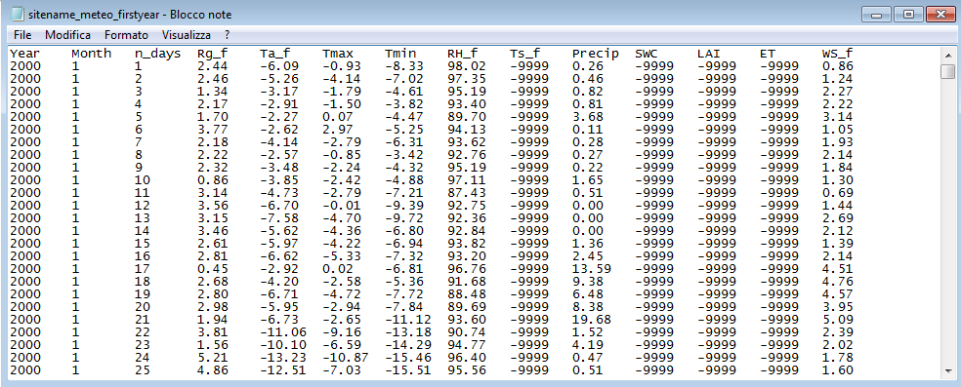
Example of meteo file
The second required input file is the meteorological data file, which is named using the start year of simulation (e.g. "sitename_meteo_2000.txt"), containing the daily meteorological data.
Years of simulation depends on the number years included in the met file.
Some met data are mandatory: temperature, precipitation, vapor pressure deficit (or relative humidity) and short-wave solar radiation, whereas others are optional.
If the model runs in "spatial version" daily or monthly LAI values are mandatory otherwise they are not considered in processes. Each variable must be separated by one-tab character. Model considers leap years, so 29th of February has to be included.
Example for year 2007-200x in daily/un-spatial version:
Year Month n_days Rg_f Ta_f Tmax Tmin VPD_f Ts_f Precip SWC LAI ET WS_f
2007 1 1 5.1 -9999 13.1 7.1 0.2 7.8 1 -9999 0
2007 1 2 6.1 -9999 10.4 5.8 0.2 6.3 0.2 0.27 0
2007 1 3 6.1 -9999 9.9 3.1 0.2 3.3 0 0.39 0
2007 1 4 6.1 -9999 10 1.9 0.2 0.5 0 0.2 0
...
Variables:
- Rg_f: Mean daily global radiation (MJ m⁻² day⁻¹)
- Ta_f: Daily average temperature (°C)
- Tmax: Daily Maximum temperature (°C)
- Tmin: Daily Minimum temperature (°C)
- VPD_f or RH_f: Daily Vapor Pressure Deficit (mbar-hPa) or Relative Humidity (%)
- Ts_f: Daily Soil temperature (°C)
- Precip: Cumulated daily precipitation (mm day⁻¹)
- SWC: Soil water content (mm m⁻²)
- LAI: Leaf area Index (m² m⁻²) (Only in spatial version)
- ET: Evapotranspiration (mm m⁻² day⁻¹)
- WS_f: Windspeed (m sec⁻¹)
NO DATA = -9999

8.3 Soil file
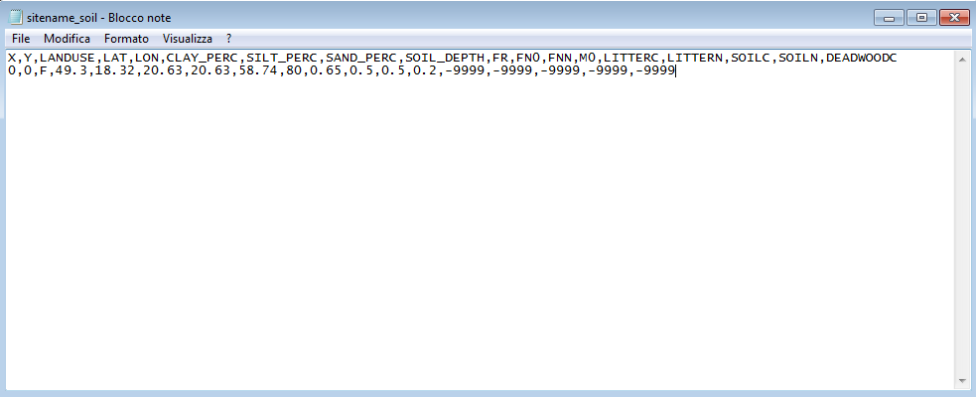
Example of soil file
The fourth required input file is "sitename_soil.txt". It contains information about soil and fertility of the test site.
Comments are allowed in the parameter file. Comments can appear almost anywhere, must begin with two forward slash characters '//', at the end of the line. Example parameter files are provided.
In general, the format of parameters file is one parameter per line, with the parameter name being enclosed in double quotes, with a tab character separating the parameter name and its value.
IMPORTANT: Values are referred to the SIZECELL dimensions specified in the setting.txt file (e.g. if SIZECELL = 100 meters -> tC ha⁻¹).
It contains the following parameters:
X,Y,LANDUSE,LAT,LON,CLAY_PERC,SILT_PERC,SAND_PERC,SOIL_DEPTH,FR,FN0,FNN,M,LITTERC,LITTERN,SOILC,SOILN,DEADWOODC
0,0,F,49.3,18.32,20.63,20.63,58.74,80,0.65,0.5,0.5,0.2,-9999,-9999,-9999,-9999,-9999

- LANDUSE: see the ‘LANDUSE’ section
- LAT: Latitude (°)
- LON: Longitude (°)
- CLAY_PERC: Soil clay (%)
- SILT_PERC: Soil silt (%)
- SAND_PERC: Soil sand (%)
- SOIL_DEPTH: Soil depth (cm)
- FR: Fertility rating (dim)
- FN0: Value of fertility modifier when FR=0 (dim)
- FNN: Power of (1-FR) in fertility modifier (dim)
- M0: Value of ‘m’ when FR=0 (dim)
- LITTERC: Litter carbon
- LITTERN: Litter nitrogen
- SOILC: Soil carbon
- SOILN: Soil nitrogen
- DEADWOODC: Dead wood carbon

8.4 Topo file
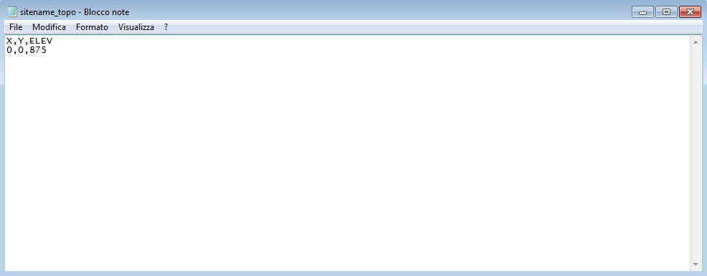
Example of topo file
The fifth required input file is "sitename_topo.txt". It contains information about topography of the test site.
Comments are allowed in the parameter file. Comments can appear almost anywhere, must begin with two forward slash characters '//', at the end of the line. Example parameter files are provided.
In general, the format of parameters file is one parameter per line, with the parameter name being enclosed in double quotes, with a tab character separating the parameter name and its value.
It contains the following parameters:
- X: 0
- Y: 0
- ELEV: Elevation from ancillary data (m)

8.5 CO₂ file
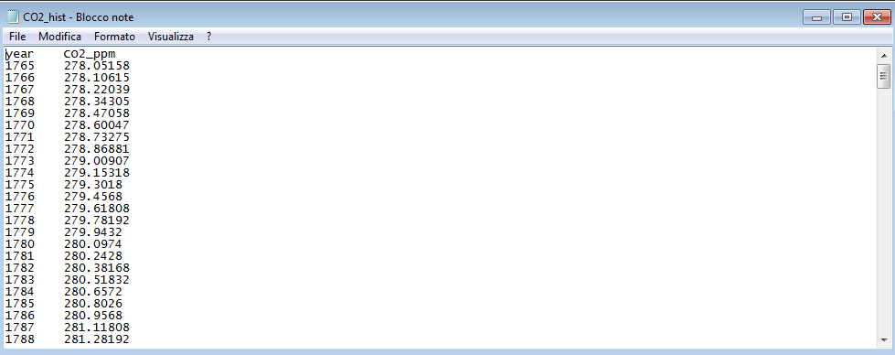
Example of CO₂ file

9. Output files

9.1 Overview
For each simulation the Model creates or rewrites into the output folder a file named "output.txt".
In this folder 4 other subfolders based on time scale should created. These files contain every result for debug (if necessary) daily, monthly and annual simulations. It is also useful to check which model functions have been used. These results can be obtained at stand level or for each type of class level (layer, dbh, age or species class) on Unix like platforms, if you need to extrapolate a variable it is advised to use the "grep" tool.
E.g. open a terminal into the output folder and for the variable NPP type:
"cat output.txt | grep 'Stand NPP' " if you want to see grep output into terminal;
"cat output.txt | grep 'Stand NPP' > NPP.txt" if you want to redirect grep output into an NPP file inside the output folder
IMPORTANT: be sure to use the correct declaration of the output as grep parameter.

9.2 Annual Outputs
At class level:
YEAR Year of simulation
LAYER Layer of tree class
HEIGHT Average height of a species (m)
DBH Average diameter at breast height of a species (cm)
AGE Age of trees (years)
SPECIES Tree Species
MANAGEMENT T = Timber
GPP Yearly Gross Primary Production (gC m⁻² year⁻¹)
GPP_SUN:GPP Yearly Gross Primary Production for sun leaves (gC m⁻² year⁻¹)
GPP_SHADE:GPP Yearly Gross Primary Production for shaded leaves (gC m⁻² year⁻¹)
Av_SUN:A_SUN Carboxylation rate/Final assimilation rate ratio for sun leaves
Aj_SUN:A_SUN RuBP regeneration/Final assimilation rate ratio for sun leaves
Av_SHADE:A_SHADE Carboxylation rate/Final assimilation rate ratio for shaded leaves
Aj_SHADE:A_SHADE RuBP regeneration/Final assimilation rate ratio for shaded leaves
Av_TOT:A_TOT Carboxylation rate/Final assimilation rate ratio
Aj_TOT:A_TOT RuBP regeneration/Final assimilation rate ratio
GR Growth respiration (gC m⁻² year⁻¹)
MR Maintenance Respiration (gC m⁻² year⁻¹)
RA Autotrophic respiration (gC m⁻² year⁻¹)
NPP Net Primary Production (gC m⁻² year⁻¹)
BP Yearly Biomass Production (gC m⁻² year⁻¹)
reser_as_diff -
ResAlloc Annual reserve allocated (tNSC cell⁻¹ year⁻¹)
ResDeple Annual reserve depleted (tNSC cell⁻¹ year⁻¹)
ResUsage Annual reserve used (tNSC cell⁻¹ year⁻¹)
BP/NPP Biomass productivity vs. Net Primary Production
ResAlloc/NPP Annual reserve allocated vs. Net Primary Production
ResAlloc/BP Annual reserve allocated vs. Biomass productivity
ResDeple/NPP Annual reserve depleted vs. Net Primary Production
ResDeple/BP Annual reserve depleted vs. Biomass productivity
ResUsage/NPP Annual reserve used vs. Net Primary Production
ResUsage/BP Annual reserve used vs. Biomass productivity
CUE Annual Carbon Use Efficiency (gC NPP gC GPP⁻¹)
BPE Biomass Production Efficiency (gC BP gC GPP⁻¹)
diffCUE-BPE CUE - BPE
Y(PERC) RA/GPP * 100
PeakLAI Peak LAI (maximum attainable LAI) (m²m⁻²)
MaxLAI Maximum of LAI (maximum reached LAI) (m²m⁻²)
SLA Specific Leaf Area (m²Kg⁻¹)
SAPWOOD_AREA Tree sapwood area (cm²)
CC-Proj Projected Canopy Cover (frac)
DBHDC DBH/Crown diameter relationship
CROWN_DIAMETER Crown Projected Diameter (m)
CROWN_HEIGHT Crown Height (m)
CROWN_AREA_PROJ Crown Projected Area (at zenith angle) (m²)
APAR Absorbed Photosynthetically Active Radiation (molPARm⁻²year⁻¹)
LIVETREE Number of live trees (ntree cell⁻¹)
DEADTREE Number of dead trees (ntree cell⁻¹)
THINNEDTREE Number of thinned trees (ntree cell⁻¹)
VEG_D Annual number of vegetative days (days year⁻¹)
FIRST_VEG_DAY First annual day of vegetative period (DIM)
CTRANSP Canopy Transpiration (mm m⁻²year⁻¹)
CINT Canopy Interception (mm m⁻²year⁻¹)
CLE Canopy Latent Heat (W m⁻²year⁻¹)
WUE Annual Water Use Efficiency (DIM)
MIN_RESERVE_C Current Minimum reserve carbon pool (tC cell⁻¹)
RESERVE_C Current Reserve carbon pool (tC cell⁻¹)
STEM_C Current Stem carbon pool (tC cell⁻¹)
STEMSAP_C Current Stem sapwood carbon pool (tC cell⁻¹)
STEMHEART_C Current Stem heartwood carbon pool (tC cell⁻¹)
STEMSAP_PERC Stem Sapwood vs. Total Stem (%age)
STEMLIVE_C Current Stem live wood carbon pool (tC cell⁻¹)
STEMDEAD_C Current Stem dead wood carbon pool (tC cell⁻¹)
STEMLIVE_PERC Live stem vs. Total stem (%age)
MAX_LEAF_C Maximum Current Leaf carbon pool (tC cell ⁻¹year⁻¹)
MAX_FROOT_C Maximum Current Fine Root carbon pool (tC cell ⁻¹year⁻¹)
CROOT_C Current Coarse Root carbon pool (tC cell⁻¹)
CROOTLIVE_C Current Coarse root live wood carbon pool (tC cell⁻¹)
CROOTDEAD_C Current Coarse root dead wood carbon pool (tC cell⁻¹)
CROOTLIVE_PERC Live Coarse Root vs. Total stem (%age)
BRANCH_C Current Branch carbon pool (tC cell⁻¹)
BRANCHLIVE_C Current Branch live wood carbon pool (tC cell⁻¹)
BRANCHDEAD_C Current Branch dead wood carbon pool (tC cell⁻¹)
BRANCHLIVE_PERC Live Branch vs. Total stem (%age)
FRUIT_C Current Fruit carbon pool (tC cell⁻¹)
MAX_FRUIT_C Annual Fruit carbon pool (tC cell⁻¹year⁻¹)
RESERVE_N Current Reserve nitrogen pool (tC cell⁻¹)
STEM_N Current Stem nitrogen pool (tC cell⁻¹)
STEMLIVE_N Current Live Stem nitrogen pool (tN cell⁻¹)
STEMDEAD_N Current Dead Stem nitrogen pool (tN cell⁻¹)
CROOT_N Current Coarse Root nitrogen pool (tN cell⁻¹)
CROOTLIVE_N Current Coarse root live wood nitrogen pool (tN cell⁻¹)
CROOTDEAD_N Current Coarse root dead wood nitrogen pool (tN cell⁻¹)
BRANCH_N Current Branch nitrogen pool (tN cell⁻¹)
BRANCHLIVE_N Current Branch live wood nitrogen pool (tN cell⁻¹)
BRANCHDEAD_N Current Branch dead wood nitrogen pool (tN cell⁻¹)
FRUIT_N Current Fruit nitrogen pool (tN cell⁻¹)
STANDING_WOOD Standing wood carbon (tC cell⁻¹)
DELTA_WOOD Annual wood increment (tC cell⁻¹year⁻¹)
CUM_DELTA_WOOD Cumulated annual wood increment (tC cell⁻¹year¹)
BASAL_AREA Individual basal area (m²ha⁻¹)
TREE_CAI Single Tree Current Annual Volume Increment (m³tree⁻¹year¹)
TREE_MAI Single Tree Mean Annual Volume Increment (m³tree⁻¹year¹)
CAI Current Annual Volume Increment (m³class⁻¹year⁻¹)
MAI Mean Annual Volume Increment (m³class⁻¹year⁻¹)
VOLUME Stem volume (m³class⁻¹)
TREE_VOLUME Single tree volume (m³tree⁻¹)
DELTA_TREE_VOL (perc) Tree volume increment (%)
DELTA_AGB Aboveground biomass increment (tC cell⁻¹year⁻¹)
DELTA_BGB Belowground biomass increment (tC cell⁻¹year⁻¹)
AGB Aboveground Biomass pool (tC cell⁻¹)
BGB Belowground Biomass pool (tC cell⁻¹)
BGB.AGB BGB/AGB
DELTA_TREE_AGB Aboveground biomass increment (tC cell⁻¹year⁻¹)
DELTA_TREE_BGB Belowground biomass increment (tC cell⁻¹year⁻¹)
C_HWP Annual harvested woody products removed from stand (tC cell⁻¹year⁻¹)
VOLUME_HWP Annual volume harvested woody products removed from stand (m³cell⁻¹year⁻¹)
STEM_RA Stem autotrophic respiration (gC m⁻²year⁻¹)
LEAF_RA Leaf autotrophic respiration (gC m⁻²year⁻¹)
FROOT_RA Fine root autotrophic respiration (gC m⁻²year⁻¹)
CROOT_RA Coarse root autotrophic respiration (gC m⁻²year⁻¹)
BRANCH_RA Branch autotrophic respiration (gC m⁻²year⁻¹)
At cell level:
gpp Gross Primary Production (gC m⁻²year⁻¹)
npp Net Primary Production (gC m⁻²year⁻¹)
ar Autotrophic respiration (gC m⁻²year⁻¹)
hr Heterotrophic Respiration (gC m⁻²year⁻¹)
rsoil Soil respiration flux (gC m⁻²year⁻¹)
rsoilCO2 Soil respiration flux (gC m⁻²year⁻¹)
reco Annual ecosystem respiration (gC m⁻²year⁻¹)
nee Annual net ecosystem exchange (gC m⁻²year⁻¹)
nep Annual net ecosystem production (gC m⁻²year⁻¹)
et Annual evapotranspiration (mm m⁻²year⁻¹)
le Latent heat flux (W m⁻²year⁻¹)
soil.evapo Annual soil evaporation (mm m⁻²year⁻¹)
asw Current available soil water (mm volume⁻¹)
iWue Annual intrinsic Water Use Efficiency (DIM)
vol Current volume (m⁻³cell)
cum_vol Cumulated volume (m⁻³cell)
run_off Current amount of water outflow (runoff) (mm m⁻²year⁻¹)
litrC Litter carbon (gC m⁻²)
litr1C Litter labile carbon (gC m⁻²)
litr2C Litter unshielded carbon (gC m⁻²)
litr3C Litter shielded carbon (gC m⁻²)
litr4C Litter lignin carbon (gC m⁻²)
cwd_C Cwd carbon (gC m⁻²)
cwd_2C Cwd unshielded (gC m⁻²)
cwd_3C Cwd shielded (gC m⁻²)
cwd_4C Cwd lignin (gC m⁻²)
soilC Soil carbon (gC m⁻²)
soil1C Microbial recycling pool carbon (fast) (gC m⁻²)
soil2C Microbial recycling pool carbon (medium) (gC m⁻²)
soil3C Microbial recycling pool carbon (slow) (gC m⁻²)
soil4C Recalcitrant SOM carbon (humus, slowest) (gC m⁻²)
litterN Litter nitrogen (gN m⁻²)
litter1N Litter labile nitrogen (gN m⁻²)
litter2N Litter unshielded cellulose nitrogen (gN m⁻²)
litter3N Litter shielded cellulose nitrogen (gN m⁻²)
litter4N Litter lignin nitrogen (gN m⁻²)
cwd_N Cwd nitrogen (gN m⁻²)
cwd_2N Cwd unshielded nitrogen (gN m⁻²)
cwd_3N Cwd shielded nitrogen (gN m⁻²)
cwd_4N Cwd lignin nitrogen (gN m⁻²)
soilN Soil nitrogen (gN m⁻²)
soil1N Microbial recycling pool nitrogen (fast) (gN m⁻²)
soil2N Microbial recycling pool nitrogen (medium) (gN m⁻²)
soil3N Microbial recycling pool nitrogen (slow) (gN m⁻²)
soil4N Recalcitrant SOM nitrogen (humus, slowest) (gN m⁻²)
solar_rad Incoming short-wave radiation (MJ m⁻²year⁻¹)
tavg Average air temperature (°C)
tmax Maximum air temperature (°C)
tmin Minimum air temperature (°C)
tday Daylight average air temperature (°C)
tnight Nightime average air temperature (°C)
vpd Vapour Pressure Deficit (hPa-mbar)
prpc Cumulated Precipitation (mm m^{–2} year^{–1})
tsoil Average soil temperature (°C)
rh Relative Humidity (%)
avg_asw Average available soil water (mm volume⁻¹)
[co2] CO2 concentration (ppmv)

9.3 Monthly Outputs
At class level:
YEAR Year of simulation
MONTH Month of simulation
LAYER Layer of tree class
HEIGHT Average height of a species (m)
DBH Average diameter at breast height of a species (cm)
AGE Age of trees (years)
SPECIES Tree species
MANAGEMENT T = Timber
GPP Gross Primary Production (gC m⁻² month⁻¹)
NET_ASS Monthly net assimilation (gC m⁻² month⁻¹)
RA Autotrophic Respiration (gC m⁻² month⁻¹)
NPP Net Primary Production (gC m⁻² month⁻¹)
CUE Monthly Carbon Use Efficiency (0→1) (gC_{NPP} gC_{GPP}^{–1})
CTRANSP Canopy Transpiration (mm m⁻²month⁻¹)
CET Canopy Evapotranspiration (mm m⁻²month⁻¹)
CLE Canopy Latent Heat (W m⁻²month⁻¹)
CC Canopy Cover
DBHDC DBH/Crown diameter relationship
HD_EFF Effective Height/Diameter ratio (DIM)
HDMAX Height (m) to Base diameter (m) ratio MAX (DIM)
HDMIN Height (m) to Base diameter (m) ratio MIN (DIM)
N_TREE Number of trees (n tree cell⁻¹)
WUE Monthly Water Use Efficiency (DIM)
Wres Reserve carbon pool (tC cell⁻¹)
WS Stem carbon pool (tC cell⁻¹)
WSL Stem live wood pool (tC cell⁻¹)
WSD Stem dead wood (tC cell⁻¹)
PWL Maximum leaf wood (tC cell⁻¹)
PWFR Maximum fine root wood (tC cell⁻¹)
WCR Coarse root biomass (tC cell⁻¹)
WCRL Coarse root live wood biomass (tC cell⁻¹)
WCRD Coarse root deadwood biomass (tC cell⁻¹)
WBB Branch biomass (tC cell⁻¹)
WBBL Branch live wood biomass (tC cell⁻¹)
WBBD Branch dead wood biomass (tC cell⁻¹)
At cell level:
gpp Gross Primary Production (gC m⁻²month⁻¹)
npp Net Primary Production (gC m⁻²month⁻¹)
ar Autotrophic respiration (gC m⁻²month⁻¹)
et Monthly evapotranspiration (gC m⁻²month⁻¹)
le Latent heat flux (W m⁻²)
asw Available soil water (mm volume^{–1})
iWue Intrinsic Water Use Efficiency

9.4 Daily Outputs
At class level:
YEAR Year of simulation
MONTH Month of simulation
DAY Day of simulation
LAYER Layer of forest structure
HEIGHT Average height of a specie (m)
DBH Average diameter at breast height of a specie (cm)
AGE Age of trees (years)
SPECIES Tree species
MANAGEMENT T = Timber
GPP Gross Primary Production (gC m⁻²day⁻¹)
Av_TOT Carboxylation rate for limited assimilation (µmol m⁻²s⁻¹)
Aj_TOT RuBP regeneration limited assimilation (µmol m⁻²s⁻¹)
A_TOT Final assimilation rate (µmol m⁻²s⁻¹)
RG Growth respiration (gC m⁻²day⁻¹)
RM Maintenance Respiration (gC m⁻²day⁻¹)
RA Autotrophic respiration (gC m⁻²day⁻¹)
NPP Net Primary Production (gC m⁻²day⁻¹)
BP Daily biomass production (gC m⁻²day⁻¹)
CUE Daily carbon Use Efficiency (gC_{NPP} gC_{GPP}^{–1})
BPE Daily biomass production efficiency (gC m⁻²day⁻¹)
LAI_PROJ LAI for Projected Area covered (at zenith angle) (m² m⁻²)
PEAK-LAI_PROJ Peak Projected LAI (maximum attainable LAI) (m² m⁻²)
LAI_EXP LAI for Exposed Area covered (m² m⁻²)
D-CC_P Projected Canopy Cover (frac)
DBHDC DBH/Crown diameter relationship
CROWN_AREA_PROJ Crown Projected Area (at zenith angle) (m²)
PAR Photosynthetically Active Radiation (molPAR m⁻²day^{–1})
APAR Absorbed Photosynthetically Active Radiation (molPAR m²day⁻¹)
fAPAR Fraction of Absorbed Photosynthetically Active Radiation (unitless)
NTREE Number of trees
VEG_D Day of vegetative period for class (Days/Year)
INT Canopy Interception (mm m⁻²day⁻¹)
WAT Canopy Water stored (mm m⁻²)
EVA Canopy Evaporation (mm m⁻²day⁻¹)
TRA Canopy Transpiration (mm m⁻²day⁻¹)
ET Canopy Evapotranspiration (mm m⁻²day⁻¹)
LE Canopy Latent Heat (W m⁻²)
WUE Water Use Efficiency (DIM)
RESERVE_C Current Reserve carbon pool (tC cell⁻¹)
STEM_C Current Stem carbon pool (tC cell⁻¹)
STEMSAP_C Current Stem sapwood carbon pool (tC cell⁻¹)
STEMLIVE_C Current Stem live wood carbon pool (tC cell⁻¹)
STEMDEAD_C Current Stem dead wood carbon pool (tC cell⁻¹)
LEAF_C Current Leaf carbon pool (tC cell⁻¹)
FROOT_C Current Fine root carbon pool (tC cell⁻¹)
CROOT_C Current Coarse root carbon pool (tC cell⁻¹)
CROOTSAP_C Current Coarse root sapwood carbon pool (tC cell⁻¹)
CROOTLIVE_C Current Coarse root live wood carbon pool (tC cell⁻¹)
CROOTDEAD_C Current Coarse root dead wood carbon pool (tC cell⁻¹)
BRANCH_C Current Branch carbon pool (tC cell⁻¹)
BRANCHSAP_C Current Branch sapwood carbon pool (tC cell⁻¹)
BRANCHLIVE_C Current Branch live wood carbon pool (tC cell⁻¹)
BRANCHDEAD_C Current Branch dead wood carbon pool (tC cell⁻¹)
FRUIT_C Current Fruit carbon pool ((tC cell⁻¹)
DELTARESERVE_C Daily allocation to reserve (tC cell⁻¹day⁻¹)
DELTA_STEM_C Daily allocation to stem (tC cell⁻¹day⁻¹)
DELTA_LEAF_C Daily allocation to leaf (tC cell⁻¹day⁻¹)
DELTA_FROOT_C Daily allocation to fine root (tC cell⁻¹day⁻¹)
DELTA_CROOT_C Daily allocation to coarse root (tC cell⁻¹day⁻¹)
DELTA_BRANCH_C Daily allocation to branch (tC cell⁻¹day⁻¹)
DELTA_FRUIT_C Daily allocation to fruit (tC cell⁻¹day⁻¹)
RESERVE_N Current reserve nitrogen pool (tN cell⁻¹)
STEM_N Current stem nitrogen pool (tN cell⁻¹)
STEMLIVE_N Current Live Stem nitrogen pool (tN cell⁻¹)
STEMDEAD_N Current Dead Stem nitrogen pool (tN cell⁻¹)
LEAF_N Current leaf nitrogen pool (tN cell⁻¹)
FROOT_N Current Fine Root nitrogen pool (tN cell⁻¹)
CROOT_N Current Coarse Root nitrogen pool (tN cell⁻¹)
CROOTLIVE_N Current Coarse root live wood nitrogen pool (tN cell⁻¹)
CROOTDEAD_N Current Coarse root dead wood nitrogen pool (tN cell⁻¹)
BRANCH_N Current Branch nitrogen pool (tN cell⁻¹)
BRANCHLIVE_N Current Branch live wood nitrogen pool (tN cell⁻¹)
BRANCHDEAD_N Current Branch dead wood nitrogen pool (tN cell⁻¹)
FRUIT_N Current Fruit nitrogen pool (tN cell⁻¹)
DELTARESERVE_N Daily allocation to reserve (tN cell⁻¹day⁻¹)
DELTA_STEM_N Daily allocation to stem (tN cell⁻¹day⁻¹)
DELTA_LEAF_N Daily allocation to leaf ((tN cell⁻¹day⁻¹)
DELTA_FROOT_N Daily allocation to fine root (tN cell⁻¹day⁻¹)
DELTA_CROOT_N Daily allocation to coarse root (tN cell⁻¹day⁻¹)
DELTA_BRANCH_N Daily allocation to branch (tN cell⁻¹day⁻¹)
DELTA_FRUIT_N Daily allocation to fruit (tN cell⁻¹day⁻¹)
STEM_AR Stem autotrophic respiration (gC m⁻²day⁻¹)
LEAL_AR Leaves autotrophic respiration (gC m⁻²day⁻¹)
FROOT_AR Fine Roots autotrophic respiration (gC m⁻²day⁻¹)
CROOT_AR Coarse Roots autotrophic respiration (gC m⁻²day⁻¹)
BRANCH_AR Branch autotrophic respiration (gC m⁻²day⁻¹)
F_CO2 CO2 fertilization effect (DIM) (as choiced in script)
F_CO2_VER CO2 fertilization effect (DIM) (Veroustraete’s version)
F_CO2_FRA CO2 fertilization effect (DIM) (Franks et al’s version)
FCO2_TR CO2 fertilization effect (DIM) (for stomatal conductance)
FLIGHT Light modifier
FAGE Age modifier (0→1)
FT Air temperature modifier (0→1)
FVPD VPD modifier (0→1)
FN Soil nutrient modifier (0→1)
FSW Soil water modifier (0→1)
LITR_C Current Litter Carbon Pool (tC cell⁻¹)
CWD_C Coarse Woody Debris Carbon (tC cell⁻¹)
At cell level:
gpp Gross Primary Production (gC m⁻²day⁻¹)
npp Net Primary Productivity (gC m⁻²day⁻¹)
ar Autotrophic respiration (gC m⁻²day⁻¹)
hr Heterotrophic respiration (gC m⁻²day⁻¹)
rsoil Soil respiration flux (gC m⁻²year⁻¹)
reco Daily ecosystem respiration (gC m⁻²day⁻¹)
nee Daily net ecosystem exchange (gC m⁻²day⁻¹)
nep Daily net ecosystem production (gC m⁻²day⁻¹)
et Daily evapotranspiration (mm m⁻²day⁻¹)
le Daily latent heat flux (W m⁻²)
soil_evapo Daily soil evaporation (mm m⁻²day⁻¹)
snow_pack Current Amount of Snow (Kg m⁻²)
asw Current available soil water (mm volume^{–1})
moist_ratio Soil moisture ratio (DIM)
iWue Daily intrinsic Water Use Efficiency (DIM)
litrC Litter carbon (gC m⁻²)
litr1C Litter labile carbon (gC m⁻²)
litr2C Litter unshielded carbon (gC m⁻²)
litr3C Litter shielded carbon (gC m⁻²)
litr4C Litter lignin carbon (gC m⁻²)
cwd_C Cwd carbon (gC m⁻²)
cwd_2C Cwd unshielded (gC m⁻²)
cwd_3C Cwd shielded (gC m⁻²)
cwd_4C Cwd lignin (gC m⁻²)
soilC Soil carbon (gC m⁻²)
soil1C Microbial recycling pool carbon (fast) (gC m⁻²)
soil2C Microbial recycling pool carbon (medium) (gC m⁻²)
soil3C Microbial recycling pool carbon (slow) (gC m⁻²)
soil4C Recalcitrant SOM carbon (humus, slowest) (gC m⁻²)
litterN Litter nitrogen (gN m⁻²)
litter1N Litter labile nitrogen (gN m⁻²)
litter2N Litter unshielded cellulose nitrogen (gN m⁻²)
litter3N Litter shielded cellulose nitrogen (gN m⁻²)
litter4N Litter lignin nitrogen (gN m⁻²)
cwd_N Cwd nitrogen (gN m⁻²)
cwd_2N Cwd unshielded nitrogen (gN m⁻²)
cwd_3N Cwd shielded nitrogen (gN m⁻²)
cwd_4N Cwd lignin nitrogen (gN m⁻²)
soilN Soil nitrogen (gN m⁻²)
soil1N Microbial recycling pool nitrogen (fast) (gN m⁻²)
soil2N Microbial recycling pool nitrogen (medium) (gN m⁻²)
soil3N Microbial recycling pool nitrogen (slow) (gN m⁻²)
soil4N Recalcitrant SOM nitrogen (humus, slowest) (gN m⁻²)
tsoil Soil Temperature (°C)
daylenght Day length

10. Questions or comments
Shall you have issues with the code or for any suggestions, please let us know. For any questions on how to parameterize or run the code, please read this file first.
Contact:
Alessio Collalti alessio.collalti@cnr.it
Gina Marano gina.marano@unina.it

